

Advocacy toolkit for

community schools

Advocacy Toolkit for Community Schools
Whether you are new to advocacy or have been a seasoned advocate for years, this toolkit is designed to help you navigate the legislative process, and develop a voice to effectively advocate to policymakers, the public, and your peers about community schools. Policymakers need to hear from you, hear your community school story and know why community schools are essential to student achievement, family engagement, and overall community development.

This toolkit is meant to help you accomplish several goals:

- To be able to comfortably and publicly discuss the benefits of community schools.

- To create a blueprint for advocating on behalf of legislation that is of importance to the community school movement.

- To provide the resources and the procedures for contacting your senator or representative to have discussions, set up site visits and further the dialogue.

- To help you develop a voice in community school advocacy.

Together we can work to achieve legislative support for the 60,000 students and families that benefit from community schools in our state. So commit yourself and those at your school to get involved in sharing the community story in a way that will lead to sustainability and continued enhancement of this way of educating and engaging students, families and communities!

Thanks for your support,

The Federation for Community Schools Team
Table of Contents
Advocacy Toolkit for Community Schools 1
Advocacy 101: Understanding the Basics 3
Advocacy as a Bill Becomes a Law 4
The Legislative Process and Advocacy 5
Policies and Budgets 5
Corresponding with your Legislator 6
Tips for Effective Letter Writing 7
Sample Email/Letter to Elected Official 8
Calling your Legislator 9
Tips for Making Effective Phone Calls 9
Sample Phone Conversation 10
Tips for Telling your Community Schools’ Story 11
Keep the Federation for Community Schools Informed 11
Meeting with Your Legislators 12
Tips for Scheduling a Meeting with your Legislator: 12
Site Visit Checklist 13
Sample Thank You Letter (After Visit/Phone Call) 14
Organizing a Site Visit 15
Sample Schedule and Timeline for Site Visit 17
Sample Information Sheet 18
Community Schools FAQ 19
Using Social Media to Advocate for Community Schools 21
Getting Started on Social Media 21
Facebook 21
Twitter 22
Dealing with Negative Comments 22
Interactions with Elected Officials 22
Sample Social Media Posts - Twitter 23
Find your Senator and Representative on Twitter 24
Examples from our 2014 Community Schools Forum 25

Advocacy 101: Understanding the Basics

Community Schools need strong advocates. Every single day, nonprofit organizations and community schools engage in advocacy that advances their work and vision. Simply put, advocacy is sharing your point of view and ideas with legislators with the objective being to generate their support for your work. It is also a great way to engage policy makers in discussion of issues constituents, like you, face in your communities.

Building relationships with elected officials takes time and effort, and is as important as intense advocacy on any single legislative issue. The goal of advocacy activities is the development of a relationship — with members of Congress as well as at the state level, with state senators and representatives, and their respective staffs. To these policy makers,

You are viewed as a credible source of information on community schools;
Your input is valued and sought; and
Your calls get returned.

You are the conduit between what is happening in their communities and to their constituents. You have a great story to share about your community school, its students, parents and community impact. You can share that story in a way that will make a difference – that is why you advocate. Telling your story in a concise way that is connected to the overall community school movement is the key to advocacy success.

As an advocate, your most meaningful contacts with your elected officials should occur when lawmakers are not embroiled in critical education debates, whether educational improvement or funding issues. You should invite them to your school for a tour, or to speak with your principal about his/her community school; to develop your relationship with them through contacts at community events; and to share important school and community information with them all the time, not just during an advocacy campaign. These efforts will result in partnerships that have a strong foundation. Partnership based on mutual respect and trust is a valuable asset when we need to turn to our legislative leaders for support and assistance regarding community school policy.

Why should you advocate?
The Federation for Community Schools plays a vital role in advocating for community schools, but we cannot do this work alone. This is where YOU join the movement.

The Federation can communicate the community school message, propose policy recommendations to support this work, analyze the impact of proposals on community schools, provide extensive data and information to legislators and their staffs, and build coalitions with other state and national groups with similar goals. But your involvement, your perspective and voice, as a constituent and community leader, is essential to make representatives care enough about the issue to listen to the arguments, pro or con, and take a position. Legislators want to know what the people in their districts think about an issue before they take a position in Springfield, IL or Washington, D.C. You, as a constituent, have that power!

When to Advocate
Your job as an advocate is never done. It is critical to remind policy makers year-round of the importance of community school and afterschool programs. Legislators may be more responsive if you develop relationships with them through continuous communication. But, it is also helpful to understand the process of policy making, so that you can effectively advocate for community schools.

Advocacy as a Bill Becomes a Law
The legislative process can be a complicated one. The following diagram is intended to help refresh your knowledge on how a bill becomes a law, and how this process can impact policy decisions that affect your community school.

The Legislative Process and Advocacy
There are several stages in the legislative process where grassroots advocacy efforts can impact the outcome.

- Bill Introduction/Sponsorship
  - Legislators can be encouraged to introduce a bill to address a specific issue, or to co-sponsor a bill introduced by another senator or representative. Obtaining a large number of co-sponsors on a bill is one strategy for gaining attention and credibility for an issue.
- Subcommittee (Federal)
  - The most important time for constituent involvement is the subcommittee stage. Legislators are not yet committed to specific bills or legislative language. Grassroots advocates can communicate their position on the issue and suggest specific provisions or language. Action by constituents of subcommittee members can be very effective at this point.
- Committee
  - Grassroots advocacy at the committee stage is also very important, especially for the state advocacy. Communications may focus on supporting or opposing specific language developed by the subcommittee; providing testimony on an issue, encouraging legislators to sponsor amendments; and asking the committee member to vote for or against the bill. Again, action by constituents of committee members can be most effective.
- Floor Vote
  - Constituent communication with all senators and representatives is important when it comes to the floor vote. Grassroots efforts at this stage focus on encouraging a legislator to either vote for or against the bill; to sponsor a floor amendment; or to vote for or against a floor amendment offered by another legislator.
- Conference
  - Opportunities for grassroots impact are more limited at the conference stage. The Conference Committee works out the differences between similar bills passed by the House and Senate. However, grassroots communications — particularly from constituents of conferees — may influence whether the House or Senate provision is accepted in the compromise bill.
- Floor Vote
  - Once a conference committee has worked out the differences between the House and Senate version of a bill, floor passage is normally routine and not impacted by further constituent communication.

Policies and Budgets
Legislation and bills are one part of the work that members of Congress and the state’s General Assembly are tasked with accomplishing. They also make critical policy and budgetary decisions ranging from what kinds of provisions are included in bills to what kinds of taskforces are formed to explore which issues. They also play a critical role in budget decisions and in deciding what kinds of programs and supports to fund, and what to cut. Many of the strategies and best practices outlined in this guide can be applied to both bill-specific advocacy , but also to advocacy in support of or opposing policy and budgetary decisions

Corresponding with your Legislator

The time-tested method of sending a written communication to your legislator remains one of the most effective ways to deliver your message to senators and representatives. What’s new, however, is that you can now deliver the message through various channels including fax or email, and through social media, like Twitter and Facebook.

However it’s received, letters and other forms of written personal communications remain probably your most effective communication tool — short of personal visits. Letters from constituents that are well-written, and briefly explain the issue and the proposal’s impact, will be noticed in a congressional office.

As a citizen, you have the right to express your opinion to your elected official. The following are some recommendations for corresponding with your elected official:

- Always be polite and courteous. Legislators and their staff are considerably less likely to respond to rude or profane letters.
- Be as concise as possible. Remember that each office has dozens of legislative issues to cover and hundreds of constituent requests each day.
- Include your home or work address in every letter, even in e-mails.
- Thank the member of Senator or Representative for taking the time to read your letter.
- Remember that correspondence with any elected official is about building an ongoing relationship and persuading them to think of you as a resource. Even if an elected official does not agree with your point of view on an issue today, they might in the future.

Personalized communication from constituents is the most effective at all levels. This guide contains tips and samples for corresponding with your legislator. You can access their contact information by using the Illinois State Board of Elections District/Official Search (http://bit.ly/1My8Koi), or the Illinois General Assembly website (http://www.ilga.gov/).

Addressing your letter to a senator or representative

Federal Lawmakers
U.S. Senator: U.S. House of Representative:
The Honorable —————(full name) The Honorable——————(full name)
United States Senate United States House of Representatives
Washington, D.C. 20510 Washington, D.C. 20515

Dear Senator——————(last name) Dear Representative——————(last name)

State Lawmakers
State Senator: State Representative:
The Honorable —————(full name) The Honorable——————(full name)
Senate of Illinois Illinois House of Representatives

Dear Senator——————(last name) Dear Representative——————(last name)
A letter/email to your Senator or Representative should include the following items:

Salutation: Dear Senator __________,

Opening Paragraph:
- State the subject of your letter
- Use the bill number or name, if available
- Identify yourself and your community school or organization

Example: “I am the resource coordinator/director of _____ Community School which annually serves _____ students and their families” or “I provide _____ programs at a community school that teach children how to _________.”

Body of Letter:
- Explain the issue simply and factually at a level the senator or representative will understand. They’re not experts!

- Give a local, personal, example of the impact of the issue to make the legislator care.

- State your position on the bill or provision, whether you support it or oppose it.

- Be polite. There’s always another issue to fight another day.

- Thank the senator or representative for their attention to the issue.

- Let the senator or representative know you are a resource for more information.

- Ask for a reply.

Tips for Effective Letter Writing

- Target the appropriate legislators (In the district where you live, and where your organization/community school is located).

- Limit the length of your letter to no more than two pages, one if possible.

- Avoid ready-made letters or modify them to deliver a unique message. Legislators are more likely to be influenced by these.

- Give your credentials when appropriate.

- Avoid personal criticism.

- Express appreciation for past or future support.

- Ask the legislator to send you a letter stating his/her position on the issue.

- Fax/email your letter to your senator or representative if the time-frame for action is short.

Sample Email/Letter to Elected Official

U.S. House of Representative:
The Honorable (full name)
(Room #) (Name) House Office Building
United States House of Representatives
Washington, D.C. 20515

Dear Representative (insert name):

We are pleased to share with you that our organization, __________, was awarded a 21st Century Community Learning Center (21st CCLC) grant. The grant has a five-year lifecycle, and we will use that funding to provide supports and services to students and families are ______________________ (list of schools you work with). We look forward to continuing and expanding our work with children and families in _______________ (your community).

There are, however, a couple of challenges with the way the state has decided to structure the funding for this grant.

First, ISBE will be funding the FY15 cohort grantees at 90% of the original funding requests. While we appreciate that this is a way to fund a larger number of applications it also means that we (and other grantees) will need to amend our plans and goals, and serve fewer children and families.

Second, the grant announcements were late in coming, and so grants that should have started with the fiscal year, on July 1st are starting now instead. There are challenges and inefficiencies inherent in trying to utilize a full year’s funding in impactful ways in only seven months.

The good news is that ISBE can solve these problems. Federal 21st CCLC guidance allows for states to make decisions about carrying over funds. This flexibility means that ISBE could set the FY15 grant levels at 50-60% of the total requested funding, and re-allocated the remaining funds over the next four years of the grant to bring the FY16-19 funding levels up to 100% of requested funding.

Shifting the funding structure in this way would ameliorate the challenges grantees face trying to effectively and appropriately use the full FY15 funding in seven months. It would also set funding for the remainder of the grant lifecycle at levels that will enable grantees to implement programs as proposed.

[Insert a story about your community school. Special programs you offer, unique needs of families you’re meeting, and outcomes]

We have respectfully asked ISBE to consider the above proposal to maximize the use of 21st CCLC funds and to enable grantees to implement programs as they were crafted in their original proposals. We are asking for your support on this issue with ISBE, as well. The changes we are recommending will enable us to serve ________ (numbers of students and families you proposed serving) students and families in our community in the most efficient and impactful way.

Sincerely,

(Insert name and address)

Calling your Legislator

The effect of the phone call is similar to that of letter writing. As with all grassroots advocacy, your call is most likely to receive attention if you have developed a personal relationship with the legislator or staffer. Often, calls are “logged” as for or against a particular issue. Sometimes, you may not get past the receptionist or intern. Nonetheless, making a well-timed call can be particularly important. And, especially when combined with calls from your colleagues on the same issue, the call may tip the balance in your favor. So, don’t hesitate to call.

The easiest way to reach your Senator or Representative it to call the U.S. Capitol Switchboard: (202) 224-3121. You can also find the direct number to any member's office by consulting the Senate phone list , the House phone list or the Illinois General Assembly site.

The easiest way to contact your State Senator or State Representative is to use the Illinois General Assembly site to find his/ her Springfield or district office number.

Whether you’re calling a member of Congress or your state-level elected officials, some guidelines remain the same.

For Whom Should You Ask?
- Ask for the senator or representative if you know them personally.
- If you don’t know the senator or representative, ask to speak with the legislative assistant who handles your issue. For most issues, that probably will be the legislative assistant who handles education issues.
- If you can’t reach a legislative assistant, leave a concise message. Legislative offices do count the number of calls they receive on an issue — pro and con — and relay that information to the senator or representative.

Tips for Making Effective Phone Calls

- Focus on a single issue, making two or three key points in your phone call.
- Have talking points — or your own notes — in front of you when you call to stay focused on the message you want to deliver.
- Make the issue local -- localize the issue to demonstrate the impact on the legislator’s own constituents.
- Clearly state the action you wish the senator or representative to take on the issue (vote for, vote against, offer an amendment, delete a provision, etc.).
- Keep your call brief — not more than three or four minutes.
- Don’t bluff if you are asked a question you can’t answer. Tell them you’ll get the answer and get back to them.
- Leave your name and telephone number with the staff to whom you’ve spoken in case they have any questions later.
- Jot down the name of the legislative assistant you spoke to and put it in your phone book. Next time, you can ask for him or her by name and begin building a relationship. Staffers are more likely to listen to and return phone calls from people they know.
- Send a thank you note. (See Sample Thank You Letter)

Sample Phone Conversation

Staff Member: Thank you for calling Representative (Name)’s office. How may I help you?

Caller: Hello, my name is (your name) from (City and State), and I am calling on behalf of (your community school/organization) and the Federation for Community Schools.

Staff Member: Wonderful, what can I do for you?

Caller: As a constituent of Representative (Names)’s district, (Insert information on why you support community schools, or any specific legislation you support specific to our work. Include why this subject is of concern to the Representative’s constituents) Remember, be brief!

Staff Member: Thank you for sharing your concerns with us, and I will relay your comments on to the member of Congress.

Caller: Thank you for this information. I appreciate you sharing my thoughts on community schools. Have a great day.

Tips for Telling your Community Schools’ Story
- Include numbers – how many students does your community school serve? How many families? How many people does your community school employ beyond classroom/ school-day staff?

- Include results – has attendance increased at your school? Have academic outcomes improved? Have disciplinary rates decreased? Has parent engagement increased, and/ or has school climate improve? IL’s state school report cards can provide information you can use, http://illinoisreportcard.com, as can your 21st CCLC evaluations and those for other funders

- Include a personal story – share how your community school has had a positive impact on an individual student or family.

- Keep it brief – consider using bullet points to outline numbers and results.

Keep the Federation for Community Schools Informed
Let the Federation know how your meeting/phone conversation went or what response you received from your email, letter, or fax. Be sure to include information on where your legislator stood on the issues you discussed.

Your participation gives the Federation valuable insight into the positions of members at the state and Federal levels and helps us identify strong supporters and those who need additional support or information. It also enables us to keep track of community school members who have good relationships with elected officials in the even that we need their support in the future. You can keep us updated by emailing Melissa Mitchell at Melissa@ilcommunityschools.org.

Meeting with Your Legislators

Face-to-face meetings are the most effective method of communicating with senators, representatives, and their staffs. In order for meetings to be successful, they also require extensive planning, an understanding of the needs of legislators and, perhaps, a rehearsal. Legislators will usually be interested in visiting your school, and staff is often searching for opportunities to use the legislator’s time at home most effectively.

Therefore, a visit to your school will often serve everyone’s interests. It is best to meet with legislators when they are home in their district offices during legislative recess, when they have fewer distractions from legislative business.

U.S. Congressional recesses are usually scheduled around holidays and for most of August. Congress normally adjourns for the year in mid-to-late fall. The state General Assembly recesses are usually scheduled around holidays, campaigns for election, and during July, August, and early September.

There are times when meetings are appropriate in legislators’ Capitol offices during legislative session. These meetings may be tied to critical legislative action, or advocacy events in Washington or Illinois.

Tips for Scheduling a Meeting with your Legislator:
- Contact the senator’s or representative’s Illinois or Washington, D.C. office and ask to speak with the appointment secretary/scheduler.

- Explain who you represent (community school/organization) and the reason you want a meeting with the senator or representative. Ask the scheduler how you can arrange a meeting.

- If you are inviting the legislator to visit your school, send a letter of invitation from the principal or your organization’s executive director.

- Ask the scheduler the amount of lead time needed to schedule a school visit and send your invitation far enough in advance.

- Inform the Federation’s staff of the meeting request and date chosen.

Site Visit Checklist
Being an effective community school advocate requires building strong relationships with your senators, representatives, and their staff. Some tips to keep in mind while you prepare before, during and after your visit with your policy maker.
Before your Visit
- Scheduling
  - Schedule individual or group visits with your elected officials.
- Prepare
  - Treat this as an important meeting by preparing in advance. The mark of a successful legislative visit is leaving the legislator with a good sense of why you were there.
- Do your Research
  - Learn about your elected official’s priority issues, and the committee on which he/she serves.
  - Bring statistics and facts about your community school/organization.
  - How can your official’s support help your community school?
During your Visit
- Arrive Early
  - If you are running late, call and let them know.
- State the Purpose of your Visit
  - Tell your elected official who you are representing (community school/organization), and what the purpose of your visit is.
- Make it Local
  - Connect the issues you are discussing to what is happening with your Senator or Representative’s state and district. Explain how your community and the policymaker’s constituents are affected and how community schools address these issues.
- Listen, Respond, and Don’t Argue
  - Your elected official might agree with you – that’s okay! Identify issues of concern or differences of opinion and respond based on your knowledge and experience.
  - Be positive and firm. Legislators generally want to help.
  - Tell the truth. Credibility is critical to a successful relationship.
  - In a team visit, work with your colleagues, allowing all to participate.
- Wrap Up the Meeting
  - The entire visit should not take longer than 20 minutes
  - Summarize your key points and positions
  - Leave fact sheets, other information relevant to community schools, and your contact information.
  - Don’t forget to thank the elective official for their time!
After your Visit
- Follow Up
  - Send a thank you letter. (See Sample Thank You Letter)
- Keep the Federation for Community Schools informed
  - Let the Federation staff know how your visit went and where your elected official stood on the issues you discussed.

Sample Thank You Letter (After Visit/Phone Call)

The Honorable (full name)
(Room #) (Name) House Office Building
United States House of Representatives
Washington, D.C. 20515

Dear Representative (insert name):

Thank you for taking the time to meet with me (include date) to talk about the importance of supporting community schools in Illinois and in your district (include district number/area). As we discussed, and as I have witnessed firsthand community schools keep children and youth safe, increases academic achievement, and helps working families. (Include any statistics/information about your community school/organization)

I look forward to meeting with you again to further discuss the ways in which we can work together to ensure the ways in which we can work together to secure funding for community schools (or include specific bill/issue discussed) throughout the state.

Sincerely,

(Name, Last Name)
(Contact Information)

Organizing a Site Visit

Inviting policy makers to visit your community school is a powerful way to help them understand the value your program brings to the community. The future of community schools lies in the level of commitment that public officials make to fund programs. By hosting a site visit, advocates can help raise awareness of the importance of community schools in your community and the need to keep this work strong in Illinois.

Elected officials spend time in their districts frequently, including when Congress or the General Assembly is in session. In Illinois, for example, General Assembly members are often in their districts on Mondays and Fridays, and on breaks in the session (this year, “spring break” is the weeks of 3/31 and 4/6). Times when elected officials are in-district provide great opportunities to organize a site visit.

The following steps provide a guide to schedule and carry out a successful site visit.

- Step 1
  - Contact your legislator. Most Congressional Senators and Representatives have more than one district office. Select the office closest to you. General Assembly members usually have one office in their district.

  - You can access their contact information by using the following sites:
    - Illinois State Board of Elections District/Official Search (http://bit.ly/1My8Koi)
    - The U.S. Senate’s website (http://www.senate.gov/general/contact_information/senators_cfm.cfm),
    - The U.S. House of Representative’s website (http://www.house.gov/representatives/find/)
    - The Illinois General Assembly website (http://www.ilga.gov/).

- Step 2
  - Identify a few dates during the next Congressional or General Assembly recess when you could host a tour of your community school, and send an invitation.

- Step 3
  - Call the district office. Tell the scheduler/legislative aide that you would like to schedule a tour of your community school for the policy maker to attend.

  - Be flexible. Provide options for dates and times if your first selection does not work. If a policy maker is not available, see if a staff person can make the visit instead.

  - Keep in mind that elected officials’ schedules can change without notice. Several days before your scheduled visit, call to confirm the site visit and have alternate dates in case you need to reschedule.

  - Remember also that sometimes an elected official will not be able to participate in the visit, but a staffer will. Staffers are responsible for sharing information and making recommendations to elected officials. They play important roles, and it can be very impactful having a staffer participate in a site visit as well.

- Step 4
  - Before the visit, identify youth, parents, program staff, school officials and community partners who would be convincing spokespeople for your program.

  - Once you have identified the spokespeople to represent your community school, give them any background material you have on the policy maker so they will feel comfortable meeting them. This is a good opportunity to share the schedule of the site visit and clarify their roles.

- Step 5
  - Congratulations! It’s the day of the site visit.

  - Have a fact sheet on your school to give to the senator or representative. Include information that demonstrates the reach and impact your community school has on children, youth, their families, and the surrounding community.

  - Take pictures of the visit!

  - After the visit ends, send a thank you letter to your legislator for attending the site visit.

The Federation for Community Schools is here to help you with legislative site visits. The Federation can take care of visit logistics and preparing any materials to distribute during the event. If you are interested in organizing a site visit at your community school, contact the Melissa Mitchell at melissa@ilcommunityschools.org or at (312) 836-0854.

Sample Schedule and Timeline for Site Visit
The following tools are intended to help you plan and coordinate your site visit successfully before and during the site visit.

Schedule – Day of Site Visit
Time | Activity
3:00 PM | Legislator/Staff arrives at the community school and is greeted by Principal, Program Coordinator, or other lead host. Have a fact sheet available to distribute. Don’t’ forget to have your camera ready to take pictures.
3:05 – 3:15 PM | Lead the Legislator/Staff on a tour of the school. Choose areas that demonstrate the impact of your community school on the academic, social, health and well-being of your students. Walk the tour yourself in advance to make sure everything is in order and that you deliver your intended message.
3:15 – 3:30 PM | Introduce Legislator/Staff to the children/youth in the program. Have them talk about their experience at the community school. Inform participants of the message you are conveying in advance so they can be prepared and supportive.
3:30 – 3:45 PM | Facilitate a discussion between parents and Legislator/Staff. Ask parents to explain how the programs and services housed at the community school helps their families.
3:45 – 4:00 PM | Have the school Principal or Resource Coordinator talk about school-wide improvement attributable to the community school.  4:00 PM - End of site visit. Follow up with a thank you letter.

Timeline
Time Prior to Visit | Activity
1 month | Invite Legislator/Staff to visit your community school. Be prepared to have various dates you can suggest. Follow up with a formal invitation via email, mail, or fax.
3 weeks | Invite parents, community members, school officials, and youth to participate in the site visit.
2 weeks | Develop schedule for the day; identify roles for spokespersons.
1 week | Finalize program agenda. This includes tour of the community school and supporting materials you will be giving the Legislator/Staff.  Meet with other people who will participate in the visit (teachers, parents, students) to discuss what role they will play, what they will talk about, what they want to share about your community school work, and what they need to tell their stories.
3 days | Call your Legislator’s office to confirm visit.
2 days | Invite media, if applicable.

Sample Information Sheet

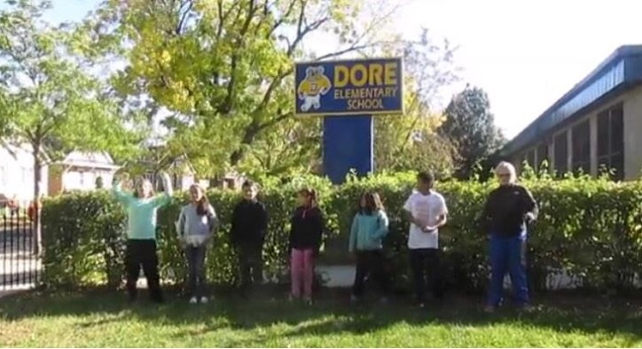
[Insert Logo]
[Insert Header/Program Name]
Include facts about your program. Describe the impacts of your program that may include social/emotional benefits or increased engagement in learning.

You can also include:
• Partnerships
• Program accomplishments
• Area/Community served

[Sub-Header C: Program Details]
Add a picture!

“Insert a quote from a student, parent or other stakeholder that reinforces key program goals and/or outcomes”

[Sub-header B: Community Needs & Program Overview]
In this section, you may include a sentence or two on the needs in your community:
• Number of children who utilize the programs and services at your community school.
• Number of parents involved
• Benefits of the community school in your community

Briefly highlight how your program addresses these challenges, and include your mission statement.

[Sub-Header A:

Quantitative Data]

- Use this space to highlight quantitative data about your community school.

- The point is to quickly grab the attention of a politician, parent, or funder with key data points that underscore the need for and success of the program.

- If you do not have data for your program, you can find nationwide and state-specific data on our website www.ilcommunityschools.org , or the Coalition for Community Schools site, www.communityschools.org

For more information, contact
Your Contact Name
Address Line
City, State, Zip
Phone
Email


Community Schools FAQ
Q. What is a community school?
A. A community school provides meaningful developmental and enrichment opportunities for students and families beyond the typical school day and year; mobilizing all the assets their communities and stakeholders have to offer. These wraparound services available through community schools provide students with programs and services that remove barriers to quality learning and provide enhanced opportunities that directly contribute to better academic performance, higher attendance rates, and improved physical and mental health. Community schools are comprehensive, and implementation and sustainability vary across the board. A community school is not only an out-of-school time program for youth; rather it is the product of a school and a community working collaboratively to support students and families. Overall, community schools enable early, comprehensive development that prepares children to be vital, contributing members of the community throughout their lives, and engaged parents and community members that build safer, stronger, and more self-sufficient neighborhoods.

Q. Who is involved in a community school?
A. For a community school to work, public schools, nonprofit organizations, and local businesses come together, using the school as a hub, to provide a broad range of programs and services to students, their families, and the community at-large.

Q. How does a community school work?
A. An essential component of a high quality community school is a full-time Resource Coordinator (RC) who is charged with meeting the holistic needs of students, families, and the community. RCs coordinate and maintain a number of resources using the school as a point of access for students and families. We use a funnel as a metaphor to help represent the important work RCs do to connect all of the services and programs students and families need to flourish under one roof: the community school. These resources, often funded with blended private and public dollars and offered through nonprofit organizations, include programs that support students’ academic and social-emotional development, activities to promote family/parent engagement, and services that may otherwise not be accessed like health screenings, financial education, and employment and training programs.

Q. What programs/services does a typical community school offer?
A. Community school program offerings vary based on local needs and resources. Community schools also engage parents as partners in their child’s education, and provide supports to ensure they are able to do so. The strategy is flexible, ensuring the needs and assets of each community are considered. However, most community schools will offer programs and services in the following categories to all students, families, and community members: Out-of-School Time and Summer Programs; Early Childhood Resources; Tutoring & Mentoring Programs; Mental Health Supports; College and Career Guidance; Arts Programs, Academic Supports & Enrichment; Healthcare and Social Services Supports; and Employment and Training Assistance.

Q. How are community schools funded?
A. Community schools braid funding provided by local, state and federal grants, which serve as a foundation to implement the community school model. Because public sources of funding are not sufficient to fully support a community school, additional funding from foundations, local business, and corporations supports the work of community schools. Having a stable funding source that supports community schools will allow for this initiative to grow and for schools to offer more comprehensive programs and supports to students and families. Specifically, partnerships are essential in the current economic climate. With budgets under continued threat and challenging economic prospects, schools must build deep and intentional relationships with community partners to expand learning opportunities.

Q. What challenges do community schools face?
A. Despite the demonstrated success and benefits of the community school model, funding for community schools continues to be limited. Community schools are expected to respond to increasing needs (like mental health supports) with decreasing resources, and schools too are forced to do more with less as their budgets continued to get squeezed. Though community schools have proven to be an effective and efficient use of public and private investments, they face increased stress and pressure as funding for afterschool programs, social services, and the foundational funding for a community school Resource Coordinator gets cut. These cuts also impact supports and limited resources available to provide these critical supports to students and families. Under these challenging and uncertain economic times, Resource Coordinators are expected to offer students and families more expanding learning opportunities after school and during the summer months. To support the community school movement in Illinois, government officials can promote policies that support the growth and strength of community school model, as well as secure funding necessary to sustain and expand community schools.

Q. Why are community schools important and how do they support academic achievement?
A. Although schools are responsible of providing quality academic programs to students during the day, research has demonstrated that academics alone is not enough to ensure student success, rather a more comprehensive menu of programs and services are needed in order to create optimal learning environment and a strong, vibrant community. Community schools are necessary because they help address the many challenges schools and educators face in underserved communities, including poverty, under resourced schools, and unstructured time. Emerging evidence in the field of education and youth development demonstrates that community schools can contribute to student academic progress as measured by decreases in grade retention and dropout, and increases in attendance, math achievement, and overall GPA. Ultimately, a student’s success (or failure) is the product of multiple and varied factors at the individual, family, and school levels. Community schools play an active role in providing a number of academic and non-academic supports and services that target all the needs that contribute to a student’s achievement gap.

Q. How many students are impacted by community schools?
A. Community schools serve more than 1.5 million students in nearly 3,000 elementary and high schools across the United States. In Illinois, there are over 175 community schools across the rural, urban, and suburban areas and many more in the early stages of development. Community schools are led by over 60 lead partners including nonprofit agencies, community-based organizations, and in some cases, the school district itself.

Q. How can I learn more about community schools?
A. For additional information, including current community school members in Illinois and how you can support the work of community schools, visit the Federation for Community Schools’ website: ilcommunityschoools.org. The Federation for Community Schools is a member coalition that works to amplify the voice abilities of community schools by creating a network to strengthen their collective impact, promote policy changes that support community schools, and provide professional development opportunities for individuals in the field.

Using Social Media to Advocate for Community Schools

Social media is a powerful tool that is changing the way people absorb information, mobilize for advocacy, and raise awareness about issue campaigns. Within minutes, organizations and individuals can amplify a singular message and spread it quickly through social media. Community schools can benefit from how quickly information can be shared and how much their follower’s networks can see their posts and activities. Online media engagement is only expected to increase in the coming years; making social media communications a valuable tool for the Federation and community schools to integrate in our advocacy efforts.

Getting Started on Social Media
If you or your community school is not already on social media, the first step is to sign up for a free account. The steps to set up an account are basic, but both Twitter and Facebook have “help” pages that will guide you through the process and give you a better understanding on how the platform works.

Once you have created an account, before you start posting content, make sure that you have a clear process for determining who will be the primary account user: Resource Coordinator, Program Staff, or Lead Partner Agency staff. There is no “right” or “wrong” person to manage your social media account; it is up to you to determine who in your group is able to take on the responsibility.

What can I tweet about? Anything you’d like to share about community school! However, if during your first trial you are unsure how things work or what content is appropriate for you to post, take some time to get a feel for how the platform works. Monitor comparable users and discover what you think works well and what does not. A good way to being putting content on out while learning how to use the platform is to share or repost what the Federation for Community Schools has posted on Twitter and Facebook. Once you start posting your own content, remember that it is all about creating engagement and conversation. You want to appeal to your audience and get their attention on issues that matter to them. Social media is a great tool to build community school awareness, both at a local and national level; it is effective for membership growth, membership participation, volunteer development, and most importantly advancing and advocating the amazing work your community school does!

Facebook
Facebook is an online social network that connects people and organizations. Users connect by friending each other or liking public figures and organizations. Members can communicate with their audience through messages, personal updates and public wall posts.

Facebook is a great way to connect to community school advocates. You can quickly share useful information with your network, and better understand how your content is performing and how you can spread your messages farther.

There are lots of ways to engage your audience on Facebook. This platform allows you to:
    - Share links to articles, petitions, surveys, and slideshows.
    - Post photos and videos that showcase your community school and students.
    - Tag other users or specific places. This increases your pages reach and visibility.
    - Make your messages conversational and brief. Get your audience members engaged and informed.


The Federation for Community School is on Facebook!
Check out and “Like” our Page - https://www.facebook.com/ilcommschools

Twitter
Twitter allows users to share short messages in 140 characters or less. Due to the brevity of its messages, Twitter is a great tool for breaking news, tracking specific topics, like community school research and initiatives, engaging with people in your field, and sharing information.

Twitter is an ideal tool for advocacy campaigns because information is delivered and received in real time. Community school advocates can live tweet from an event or meeting to give followers updates and information about the setting. This platform allows you to:
    - Bring your message to the attention of another user, like your elected officials, funders, and other community school advocates. You can reply or “retweet” a post to include these individuals or organizations.
    - Share links to articles, petitions, surveys, and slideshows.
    - Post photos and videos that showcase your community school and students.
    - Join or create a conversation about a specific topic by adding a hashtag (#) to your tweet. Some important hashtags to follow and use for the Federation are: #Communityschools, #Invest3to6, and #Opp4All.

The Federation for Community School is on Twitter!
Follow Us - @ILCommSchools

Dealing with Negative Comments
Negative comments are an inevitable part of social media, especially around issues that people feel passionately about, like community school funding and cuts. To be a successful advocate on social media, you have to willing to take the good with the bad and recognize that you cannot control what others say – you can only control how you react to those comments. Engagement on social media is a sign that your advocacy efforts are attracting attention and that people are interested in sharing their opinions, both positive and constructive.

In many cases, you might be inclined to delete a post that you find disagreeable or contrary to your own opinion. If you delete every post that you find objectionable, you may escalate the problem or alienate users on your page. Grounds for deleting a post include:
    - Use of profanity or derogatory language.
    - Personal insults or disrespectful language against another user
    - Spam
    - Overly solicitous content

Interactions with Elected Officials
It is okay to interact with elected officials, at both the Federal and state levels, on social media. In fact, using your community schools’ Facebook and Twitter accounts to reach out to your elected officials to support or oppose legislation is an excellent way to make your voice heard for every child and youth you represent. Our Sample Social Media Posts includes the Twitter handles for your State Senators and Representatives.

Sample Social Media Posts - Twitter

Make your voice count!
Tell your Senator and Representative how 21st CCLC supports Community Schools in Illinois

As Congress moves to reauthorize the Elementary and Secondary Education Act (ESEA), also known as No Child Left Behind, it is critical to students, families and communities in Illinois that the 21st Century Community Learning Center (CCLC) program is maintained as a separate and specific federal funding stream for school and community partnerships that provide vital afterschool and out-of-school time programs.

Rep. John Kline (R-MN), who leads the House Education and the Workforce Committee, is moving towards a vote on the House rewrite of ESEA soon. This debate provides the perfect opportunity for community school advocates to take action and support funding for afterschool programs. With significant cuts being proposed to dedicated afterschool and 21st CCLC funding in both the House and Senate, community schools are expected to respond to increasing needs with fewer resources; affecting thousands of low-income students and their families in urban, suburban, and rural communities in Illinois and across the country.

What can you do? We are asking community school stakeholders to use social media to share with their Senators and Representatives why 21st CCLC is important for students and families in our state. You can make an even greater impact by sharing this action with your friends and family too! It’s simple, and only takes 140 characters!

Here are a few Tweets to get you started:
(Be sure to insert your Representative’s handle from page 2)

- #21CCLC provides #afterschool programs to low-income students & families in #IL. @InsertRepHandle, support #communityschools #Invest3to6!

- @InsertRepHandle -1 Million kids in #IL could benefit from an #afterschool program. #Invest3to6 so #communityschools can meet this demand!

- @InsertRepHandle, #Invest3to6 to keep kids safe and engaged in #afterschool programs. #Communityschools can't afford #21CCLC cuts.

- In #IL, 65,000 students & 11,000 adults count on #communityschools each day.@InsertRepHandle, #Invest3to6 - don't cut #21CCLC funding!

- 84% of parents support public funding for #afterschool programs.@InsertRepHandle, keep #communityschools strong in #IL! #Invest3to6!

- #21CCLC allows #communityschools to [personalize this Tweet!].@InsertRepHandle, #Invest3to6!

These sample tweets include hashtags (#) that connect the work of community schools and afterschool supporters here in Illinois, to a greater national movement that has the potential to make a real impact. Join us and be part of a national campaign to support afterschool and 21st CCLC funding!

Thanks for your support,
The Federation for Community Schools Team

Find your Senator and Representative on Twitter

House
District | Name | Twitter Handle
1 | Bobby Rush | @RepBobbyRush
2 | Robin Kelly | @RepRobinKelly
3 | Dan Lipinski | @RepLipinski
4 | Luis Gutiérrez | @RepGutierrez
5 | Michael Quigley | @RepMikeQuigley
6 | Peter Roskam | @PeterRoskam
7 | Danny Davis | @RepDannyDavis
8 | Tammy Duckworth | @RepDuckworth
9 | Jan Schakowsky | @Janschakowsky
10 | Robert Dold | @RepDold
11 | Bill Foster | @RepBillFoster
12 | Mike Bost | @RepBost
13 | Rodney Davis | @RodneyDavis
14 | Randy Hultgren | @RepHultgren
15 | John Shimkus | @RepShimkus
16 | Adam Kinzinger | @RepKinzinger
17 | Cheri Bustos | @RepCheri
18 | vacant
Senate
 | Dick Durbin | @SenatorDurbin
 | Mark Kirk | @SenatorKirk

Examples from our 2014 Community Schools Forum

Harnessing the Power of Partnership to Promote Equity through Community Schools
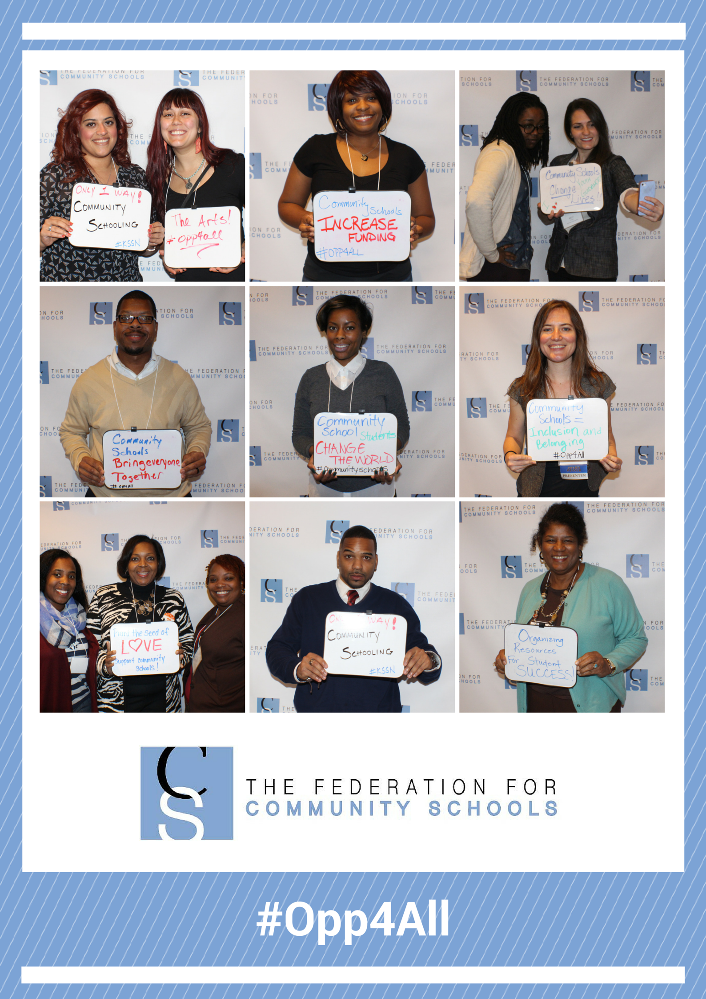

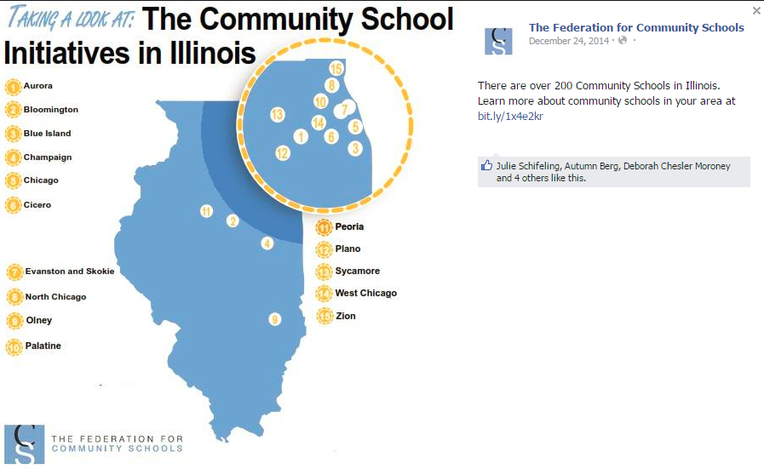
Community Schools in Illinois

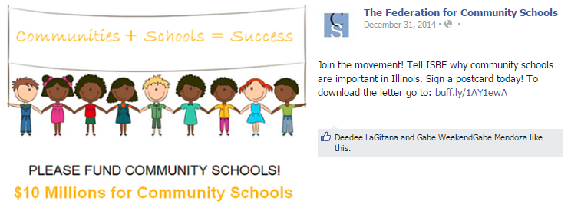
$10 Million for Community Schools Campaign

33 West Grand Avenue, Suite 300
Chicago, Illinois 60654
(312) 836-0854
www.ilcommunityschools.org

PTA National http://www.pta.org/files/Advocacy%20Toolkit-Corresponding%20With%20Congress.pdf
National Afterschool Alliance http://www.afterschoolalliance.org/reachPolicySiteVisit.cfm
National PTA Advocacy Toolkit http://www.pta.org/advocacy/content.cfm?ItemNumber=3892

